Instructions on using the Student firewall to gain access to servers when off-campus

1. Type in your browser: <https://studentfw.mc3.edu/>
2. You will then be prompted with a login box like the following:

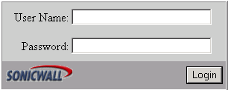

1. In the User Name: box type **your MCCC login id** . In the Password box enter **your MCCC password** (the password is case sensitive).
2. You will then be prompted with the following:

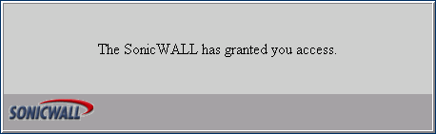

1. If you see this dialog box than you can access all servers that are behind the firewall. If you do not see the above box, you might have the Caps Lock key turned on, check and reenter information. If you continue to have problems, please call the help desk at 215-641-6495 from off campus and 6495 from on campus.
2. You will also be prompted with a secondary User Login Status window. This window has some basic information on it, as well as a Logout button. You can leave this window open (minimize it), and log out when you are completed, or close the window and your connection will be terminated after the specified time.

